DMart Pricing & Assortment
Strategy Analysis Report
A Full Exploratory, SQL & NoSQL Analysis of DMart's Product Catalog
Prepared as a Data Analytics Portfolio Project
Dataset: DMart Product Catalog (5,181 SKUs)

Table of Contents

1. Executive Summary
This report presents a full exploratory, SQL, and NoSQL (MongoDB) analysis of DMart's product catalog, covering 5,181 unique SKUs across 21 categories and 822 brands. Since the available dataset captures product listings, pricing, and discounting rather than transaction-level sales, the analysis is framed around pricing strategy, discount behavior, and assortment composition — the levers most directly observable and actionable from this data.
Three headline findings emerge. First, DMart applies sharply differentiated discounting by category: staple, high-frequency categories such as Grocery and Packaged Food carry modest average discounts (27–29%), while discretionary, low-SKU-count categories such as Electronics & Accessories and Backpacks are discounted far more aggressively (52–60%), consistent with a clearance/impulse-purchase strategy in those categories. Second, DMart's private label (“Unbranded/DMart”) is the single largest brand by SKU count and holds 100% category share in Fruits & Vegetables, Plant Containers, and Tableware — indicating zero branded competition in these segments. Third, the catalog is heavily weighted toward Budget and Mid price bands across all major categories, reflecting a value-led market positioning.
The report concludes with concrete recommendations and a proposed scope for a live monitoring dashboard.

2. Business Problem Statement
DMart's product portfolio spans over 5,000 SKUs across 21 categories and 822 brands. Category and pricing leadership require visibility into:
- Whether current discounting strategy is consistent and deliberate across categories, or inconsistent and potentially leaving margin or competitiveness on the table
- The extent of private-label penetration and brand concentration risk by category
- Whether assortment depth (number of SKUs per sub-category) is balanced relative to category importance
- Where pricing inconsistencies or extreme outlier-priced products may need review
This analysis answers these questions using the available product catalog data, applying SQL and NoSQL query techniques to validate findings across two database paradigms.

3. Data Source & Methodology

3.1 Data Source
The dataset is a real, publicly available DMart product catalog extract containing product name, brand, price, discounted price, category, sub-category, pack quantity, and product description fields. It reflects a snapshot of listed products rather than transactional sales history; no order dates, quantities sold, or customer identifiers are present. The analysis is therefore scoped to pricing, discounting, and assortment strategy rather than sales-volume trends.

3.2 Data Cleaning Steps
- Removed 5 exact duplicate rows and rows with missing core identifiers
- Corrected 13 mis-categorized rows where a brand name had been scraped into the Category field; reassigned using product-name keyword matching
- Standardized 21 inconsistent Sub-Category labels using the BreadCrumbs hierarchy field
- Parsed free-text Quantity strings (e.g. “500 gm”, “2x1L”) into numeric value + standardized unit fields, including multi-pack notation
- Derived Discount Amount and Discount % from Price and Discounted Price
- Created a Price Band classification (Budget / Mid / Upper-Mid / Premium) for market positioning analysis
- Cleaned the noisy Description field (which mixed country-of-origin tags with long marketing paragraphs) into a standardized Origin field
Final clean dataset: 5,181 rows × 14 columns, with zero nulls in all core analytical fields.

4. Exploratory Data Analysis

4.1 Catalog Composition
Personal Care, Packaged Food, Grocery, and Home & Kitchen are DMart's four largest categories by SKU count, together accounting for the majority of the catalog.
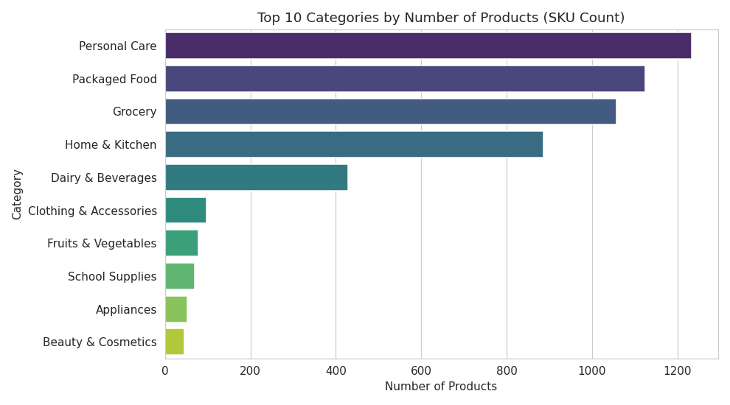
Figure 1: Top 10 categories by number of products listed

4.2 Discounting Behavior
Average discount percentage varies sharply by category. Electronics & Accessories, Smartwatches, and Backpacks carry the steepest average discounts (52–60%), while everyday staples like Grocery and Packaged Food sit around 27–29%.
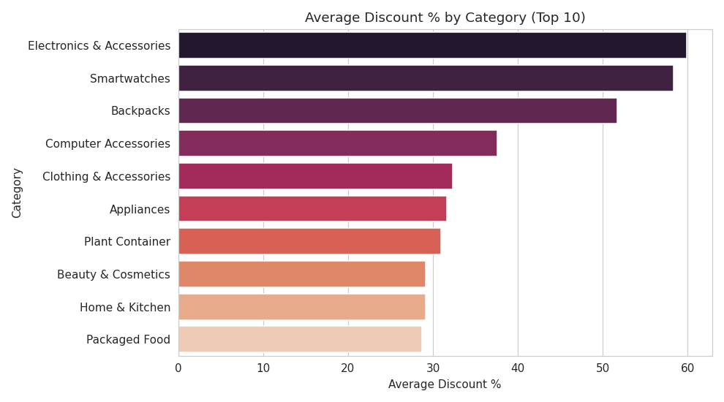
Figure 2: Average discount % by category (top 10)
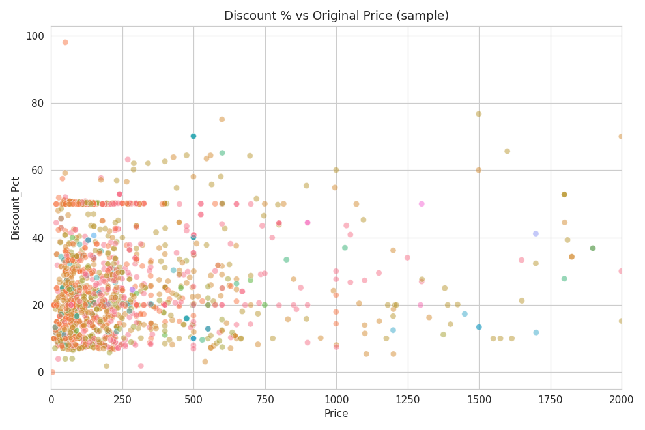
Figure 3: Discount % vs. original price across a representative product sample

4.3 Price Distribution & Positioning
The median discounted price across the catalog is approximately Rs.175, with a long right tail of premium-priced products (appliances, furniture-adjacent items). Average price is Rs.344, pulled upward by these outliers.
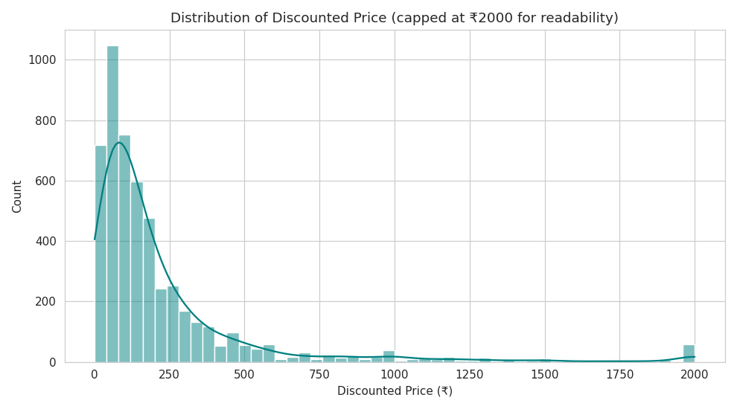
Figure 4: Distribution of discounted price (capped at Rs.2,000 for readability)
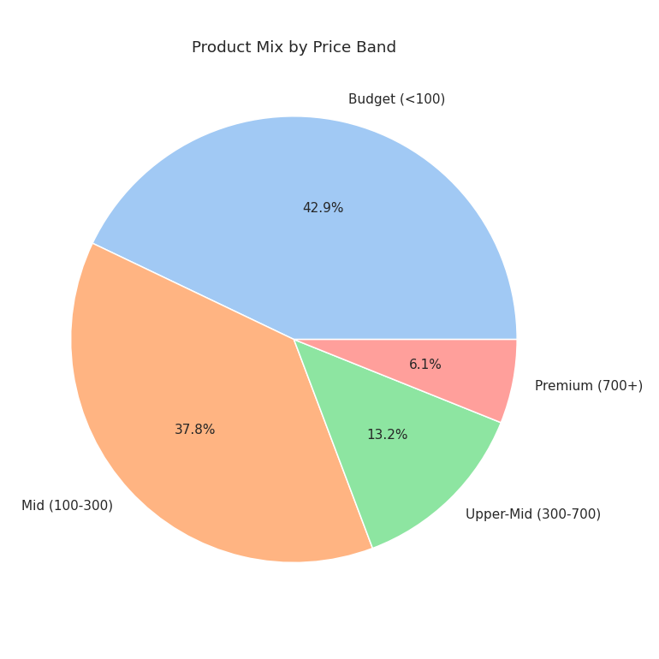
Figure 5: Overall product mix by price band

4.4 Brand Landscape
“Unbranded/DMart” (the private label) is the single largest brand by SKU count, ahead of any individual branded supplier — a strong signal of private-label strategy depth.
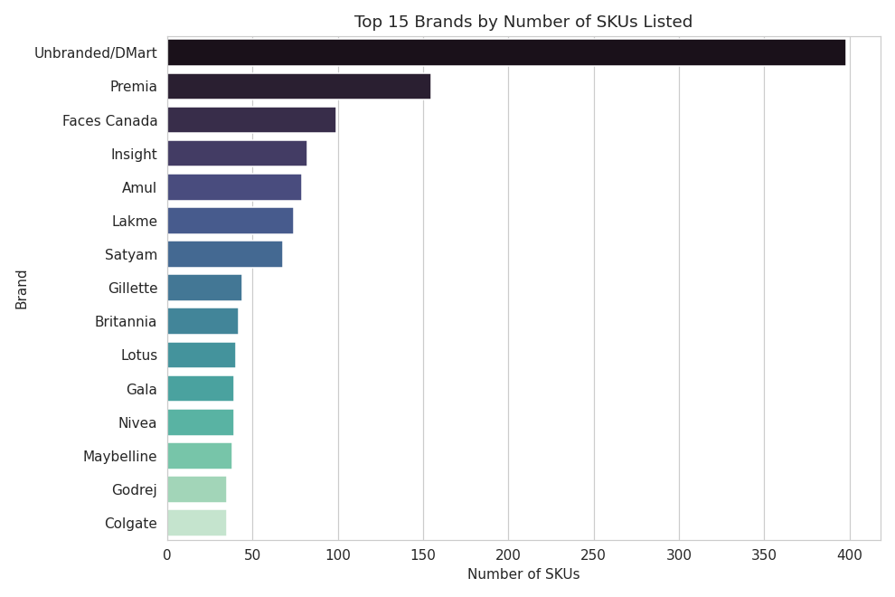
Figure 6: Top 15 brands by number of SKUs listed
Brand concentration varies dramatically by category. DMart's private label fully owns Fruits & Vegetables, Plant Containers, and Tableware (100% share), while Personal Care, Packaged Food, and Dairy & Beverages are led by established branded players (Faces Canada, Britannia/Parle, Amul).
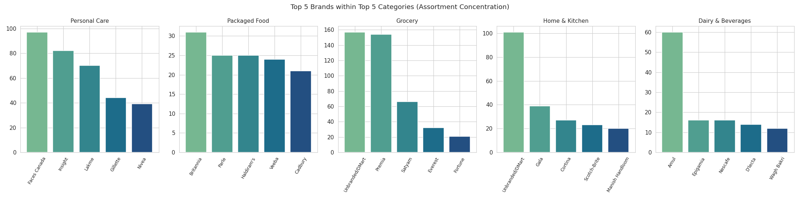
Figure 7: Top 5 brands within top 5 categories

4.5 Assortment Depth
Snacks & Farsans, Masala & Spices, and Beverages are the deepest sub-categories by SKU count, suggesting these are treated as high-priority assortment areas.
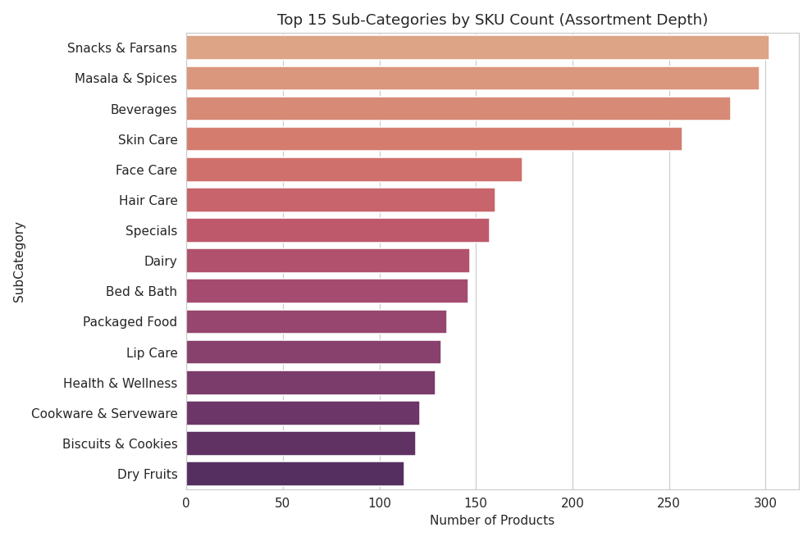
Figure 8: Top 15 sub-categories by SKU count

5. SQL Analysis (SQLite)
The cleaned dataset was loaded into a SQLite database to answer specific business questions using SQL aggregate, window, and join operations.

5.1 Which categories receive the deepest average discount?
Category | Avg Discount % | SKU Count
Electronics & Accessories | 59.87 | 7
Smartwatches | 58.34 | 1
Backpacks | 51.73 | 13
Computer Accessories | 37.62 | 2
Clothing & Accessories | 32.36 | 97

5.2 Which brands command the highest average price? (min. 5 SKUs)
Brand | Avg Price (Rs.) | SKU Count
Boat | 3,275.71 | 7
Wonderchef | 2,970.00 | 10
Usha | 2,398.00 | 10
Crompton Greaves | 2,304.45 | 11
Prestige | 2,158.93 | 14

5.3 Which brand dominates each top category? (brand concentration)
Category | Brand | SKU Share of Category
Fruits & Vegetables | Unbranded/DMart | 100.00%
Plant Container | Unbranded/DMart | 100.00%
Raincoat | Zeel | 100.00%
Tableware | Unbranded/DMart | 100.00%
Dairy & Beverages | Amul | 39.47%

5.4 Which products are priced as extreme outliers vs. their category average?
Using a window-function join comparing each product's price to its category average, several outlier premium products were identified, including the Philips UV-C Disinfection System (Rs.10,990, vs. a Home & Kitchen category average of Rs.503) and Bathla step ladders (Rs.7,000–9,000 range). These outliers materially skew category-level average price statistics and should be excluded or treated separately in pricing benchmarks.

5.5 Which individual products carry the steepest discounts?
Product | Category | Discount %
Naagin Indian Hot Sauce (3 variants) | Packaged Food | 98.00%
Disposable FFP2 Face Mask | Grocery | 85.88%
Geep Micro USB Charging Cable | Electronics & Accessories | 83.61%
Syska LED Bulb B22 6500K | Grocery | 77.81%
Trident Comfort Living Bath Towel | Grocery | 75.13%

6. NoSQL Analysis — MongoDB Aggregation Pipeline (Bonus)
To complement the relational SQL analysis and demonstrate NoSQL querying skills, the same cleaned dataset was loaded into a MongoDB-compatible document store and queried using aggregation pipelines ($group, $match, $sort, $project). The same business questions were re-run as pipelines to cross-validate results.
Note: this environment does not have outbound network access to a live MongoDB server, so the aggregation pipelines were executed against mongomock, a library that fully replicates MongoDB's query and aggregation engine in-memory. The pipeline syntax is identical to production MongoDB / Atlas — the same scripts run unchanged against a live MongoDB connection via pymongo.

6.1 Sample Pipeline — Average Discount % by Category
db.products.aggregate([
{ $group: { _id: "$Category", avg_discount_pct: { $avg: "$Discount_Pct" }, sku_count: { $sum: 1 } } },
{ $sort: { avg_discount_pct: -1 } },
{ $limit: 10 }
])
Results matched the SQL output exactly (Electronics & Accessories: 59.87%, Smartwatches: 58.34%, Backpacks: 51.73%), confirming consistency across both query engines.

6.2 Other Pipelines Run
- Top brands by average price (grouped, filtered on SKU count ≥ 5)
- Brand concentration per category (grouped by category + brand composite key)
- Price band distribution faceted by category
- Top 10 most discounted individual products
Full pipeline code and raw output are included in the accompanying project files (mongo_queries.py, mongo_results.json).

7. Key Findings & Recommendations

7.1 Findings
- Discounting strategy is category-tiered: staples are discounted conservatively (27–29%) while discretionary/low-volume categories are discounted heavily (50–60%), consistent with a deliberate margin-protection-on-staples, clearance-on-discretionary approach
- Private label (“Unbranded/DMart”) is the single largest brand overall and holds full category control in Fruits & Vegetables, Plant Containers, and Tableware — these categories have zero branded competition, which is both a strength (margin control) and a risk (no price/quality benchmark from competitors)
- A small number of premium outlier products (Rs.5,000+) sit in categories otherwise priced under Rs.500 on average, distorting category pricing benchmarks and potentially confusing positioning
- Catalog is heavily Budget/Mid-tier weighted across all major categories, reinforcing DMart's value-retail positioning
- A handful of products show 0% discount or even data inconsistencies (Discount % implausibly high at 98%, e.g. Naagin Hot Sauce at Rs.50 → Rs.1), suggesting either genuine flash-clearance pricing or data entry/scraping errors worth validating against source

7.2 Recommendations
- Audit categories with 100% private-label share (Fruits & Vegetables, Plant Containers, Tableware) to confirm this is an intentional strategy rather than a listing/catalog gap
- Review extreme-discount SKUs (>75%) for data accuracy before using them in any pricing or promotions reporting
- Consider separating outlier premium products into a distinct “Premium/Appliance” sub-segment so category average pricing remains a meaningful benchmark
- Standardize discount strategy documentation by category tier (staple vs. discretionary) to ensure the pattern observed here is intentional company policy, not incidental

8. Recommended Scope for a Live Monitoring Dashboard
This static analysis naturally extends into a live dashboard (e.g. Power BI / Tableau) for ongoing monitoring. Recommended scope:
- Category-level KPI cards: SKU count, average price, average discount %, refreshed on each catalog pull
- Discount distribution monitor: flag SKUs with discount % outside expected category range (outlier/data-quality alerting)
- Brand concentration tracker: highlight categories crossing a private-label share threshold (e.g. >80%)
- Price-band mix trend: track Budget/Mid/Premium SKU mix shift over time, by category
- New SKU / discontinued SKU tracker, once multiple catalog snapshots over time are available
Importantly, a future version of this dashboard would benefit from true transactional data (orders, quantities sold, dates) to extend from pricing/assortment monitoring into actual sales performance, demand forecasting, and customer-level analysis — the logical next phase of this project.

9. Appendix
Accompanying project files: clean_data.py (cleaning pipeline), eda.py (chart generation), sql_queries.py (SQL business questions), mongo_queries.py (MongoDB aggregation pipelines), and the cleaned dataset DMart_clean.csv.

